Student Performance Prediction System

Project Id: AIML-17

Name : Vanshika Ahuja (Team Leader)
Class Roll Number:74
University Roll Number : 2028900
Section and Group: K G2

Name : Priyanka Rawat (Member2) Class Roll Number:63
University Roll Number :2028807
Section and Group: K G2

TABLE OF CONTENTS
- Problem Description................................................................................................ 3
  - Dataset Description ............................................................................................ 3
  - Flow diagram ...................................................................................................... 4
- Modules for Project Implementation…………………..…………………………5
  - Modules Used ..................................................................................................... 5
  - Platform Used ......................................................................................................6
- Machine Learning model/ Searching Technique used ............................ 7
- Evaluation metrics used .............................................................................. 8
- Results and Visualizations ........................................................................... 9
- Conclusion and Future Scope ..................................................................... 11
- References .................................................................................................... 12

1. Problem Description
Design and develop an end-to-end machine learning system to predict user movie
preferences based on Netflix user rating history. The project should involve selecting a
suitable dataset containing user IDs, movie IDs, ratings, and timestamps. Preprocessing should include handling missing values, cleaning duplicate records, normalization of rating values, and transformation of categorical attributes (user/movie IDs encoding). Relevant features such as user viewing behavior, movie popularity, genre, and historical rating patterns should be identified using feature selection techniques. The system should include model training using Logistic Regression, KNN, and SVM classifiers to classify user preference categories (such as Like/Dislike or High
Rating/Low Rating).
The models should be evaluated using classification performance metrics including accuracy, precision, recall, F1-score, confusion matrix, and ROC curve. The project should demonstrate a complete ML pipeline from raw rating dataset to evaluated predictive models.
Expected Output:
1 : High Rating / Recommended
0 : Low Rating / Not Recommended

1.1 Dataset Description

The table shows a tabular dataset where each row represents a single interaction between a user and a movie.

Column-by-Column Breakdown
Column Name | Data Type | Description
userId | Integer | A unique identifier for each user in the system.
movieId | Integer | A unique identifier for each movie.
rating | Float/Int | The score given by the user to the movie (typically on a scale of 1 to 5).
timestamp | BigInt | The time the rating was recorded, represented in Unix Epoch time (seconds since Jan 1, 1970).
movie_title | String | The full name of the movie, often including the release year in parentheses (e.g., Toy Story (1995)).
genres | String | Categories the movie falls into (e.g., Animation, Children's, Comedy), usually separated by a pipe (|) symbol.

Key Features for Your Project
- Collaborative Filtering: You can use userId, movieId, and rating to find patterns between similar users.
- Content-Based Filtering: The genres and movie_title columns allow you to recommend movies based on their actual content or category.
- Target Variable: In your architecture, you mentioned converting ratings to 0/1. This turns the problem into a Binary Classification task (e.g., Rating $\ge 3.5$ becomes "Recommended").
- Feature Engineering: As per your flowchart, you can derive new features like Movie Popularity (count of ratings per movieId) or User Activity (average rating given by a userId).

1.2 Flow Diagram

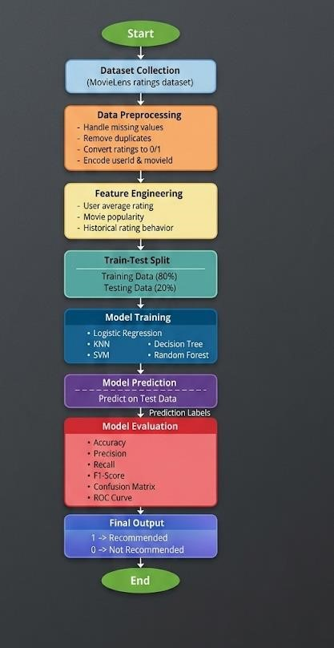

2. Modules for Project Implementation

2.1 Modules Used(mention all the inbuilt/ custom modules used and the purpose)

Explain all the inbuilt / custom modules imported and the functions used from that module. e.g.-
1. Pandas – Pandas module has been used for data manipulation and analysis. Functions used:
pd.read_csv- to read data from csv file in a pandas dataframe.

2.2 Platform Used: (mention all the platforms with the reason of using

it)
• Jupyter notebook:For code writing, testing, and debugging.
Jupyter is equipped with multiple extensions, debugger which enhance the
development experience.

3. Machine Learning Model/ Searching Technique Used(Describe each ML model/ searching technique used)

1. Logistic Regression
Logistic Regression is a supervised learning algorithm used for binary classification. It predicts the probability of a movie being liked or not liked using a sigmoid function. In this project, it is used to classify user preferences into recommended (1) and not recommended (0).

2. K-Nearest Neighbors (KNN)
KNN is a non-parametric algorithm that classifies a data point based on the majority class of its nearest neighbors. It uses distance measures such as Euclidean distance to find similar users or movies and predict preferences accordingly.

3. Support Vector Machine (SVM)
SVM is a powerful classification algorithm that finds the optimal hyperplane to separate data into different classes. It works well with high-dimensional data and helps improve classification accuracy in the recommendation system.

4. Decision Tree
Decision Tree is a rule-based algorithm that splits data into branches based on feature values. It makes decisions using a tree-like structure and is easy to interpret, helping to understand how predictions are made.

5. Random Forest
Random Forest is an ensemble learning method that combines multiple decision trees to improve prediction accuracy and reduce overfitting. It provides better generalization and robustness compared to a single decision tree.

4. Evaluation metrics used (Describe each evaluation metric used along with formulae)
1. Accuracy
Accuracy measures the overall correctness of the model.
Formula:
Accuracy=(TP+TN)/(TP+TN+FP+FN)
Where:
- TP = True Positive
- TN = True Negative
- FP = False Positive
- FN = False Negative

2. Precision
Precision measures how many predicted positive values are actually correct.
Formula:
Precision=TP/(TP+FP)

3. Recall (Sensitivity)
Recall measures how many actual positive cases are correctly identified.
Formula:
Recall=TP/(TP+FN)

4. F1-Score
F1-score is the harmonic mean of precision and recall.
Formula:
F1=(2×Precision×Recall)/(Precision +Recall)

5. Confusion Matrix
A confusion matrix is a table used to evaluate classification performance by comparing actual and predicted values.
Predicted Positive Predicted Negative
Actual Positive TP FN
Actual Negative FP TN

6. ROC Curve (Receiver Operating Characteristic)
ROC curve is a graphical representation of the model’s performance, showing the relationship between True Positive Rate and False Positive Rate.
TPR={TP}{TP + FN}
FPR ={FP}{FP + TN}

7. AUC Score (Area Under Curve)
AUC represents the area under the ROC curve and indicates the model’s ability to distinguish between classes.
• AUC = 1 → Perfect model

• AUC = 0.5 → Random guessing ll

5. Results and Visualizations

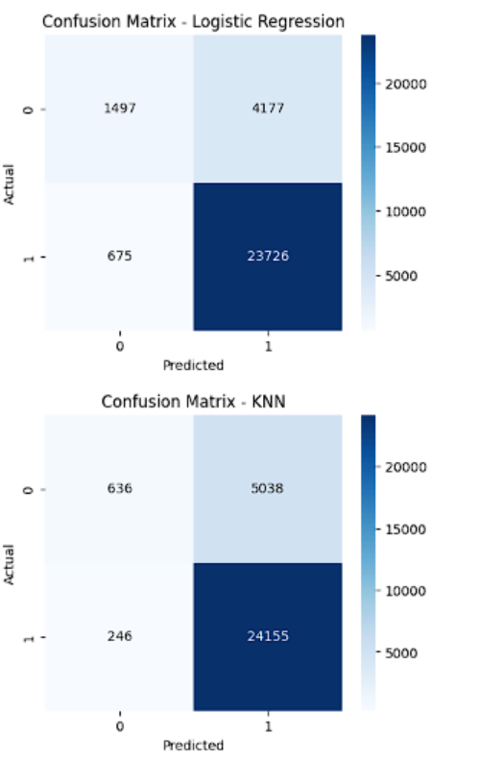

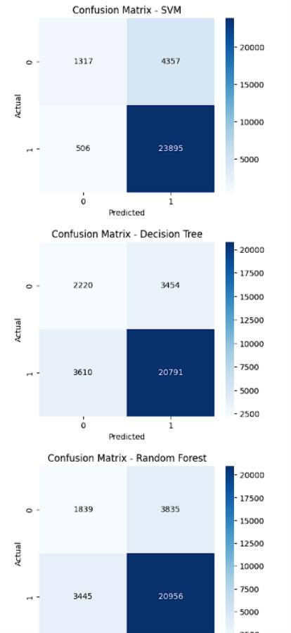

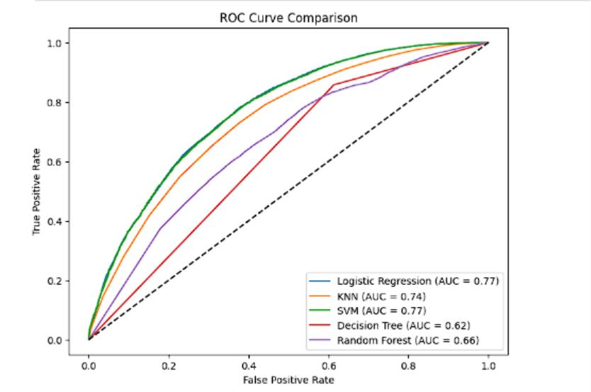
Fig.3
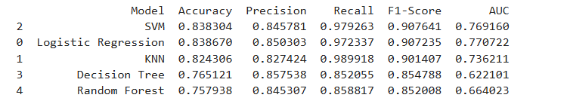

6. Conclusion and Future Scope:
Conclusion
In this project, a machine learning-based system was developed to predict user movie preferences using historical rating data. Various classification models including Logistic Regression, KNN, SVM, Decision Tree, and Random Forest were implemented and evaluated using performance metrics such as accuracy, precision, recall, F1score, and ROC-AUC. The results showed that the model can effectively classify movies as recommended or not recommended. The best-performing model was selected and successfully tested on new unseen data, demonstrating its ability to generalize and provide reliable predictions. This system can help improve personalized movie recommendation services.

Future Scope
The project can be further improved by incorporating more advanced techniques such as deep learning models and collaborative filtering methods. Additional features like movie genres, user demographics, and textual data can be included to enhance prediction accuracy. Realtime recommendation systems can also be developed by integrating the model into web or mobile applications. Furthermore, techniques like hyperparameter tuning and large-scale datasets can be used to improve performance and scalability.

7. References:
- Books:
Machin Learning with python for everyone – Mark E.Fenner
•
- Online Resources:
- GeeksforGeeks – https://www.geeksforgeeks.org/
- TutorialsPoint – https://www.tutorialspoint.com/cprogramming/index.htm

